# DASHBOARD 1 DETAILS:

**Road accident analysis** dynamic and interactive dashboard. First of all, we gathered the requirements from the user that include primary and secondary kpis. Upload our excel file on power bi.

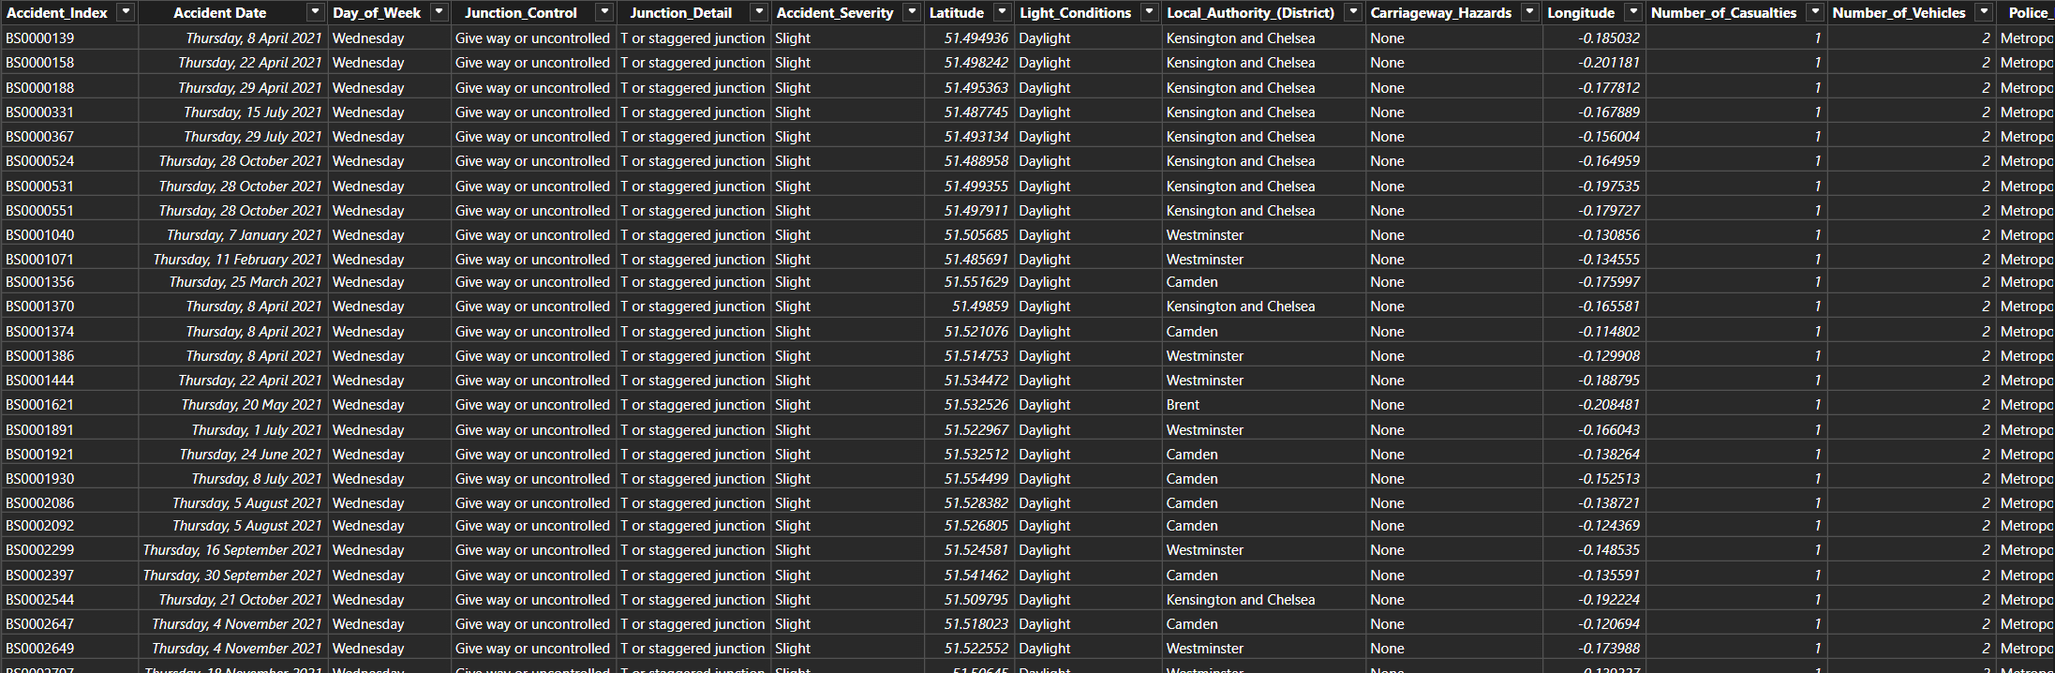

## Cleaning:

Next step we performed is data cleaning in which I deal the misspell and replace the miss spell word with right spelling, looked for any missing value in the data view tab.

## Processing:

Then opened power editor to include a new table of calendar into the model as we are dealing with time series data so we need calendar table with overall date according to our data as well as month and year by using a function called CALENDAR (time intelligence functions). By adding a new column.

Calendar = CALENDAR(MIN(Data[Accident Date]),MAX(Data[Accident Date]))

Year = YEAR(Calendar[Date])

Month = FORMAT(Calendar[Date],"mmm")

Month Number = MONTH(Calendar[Date])

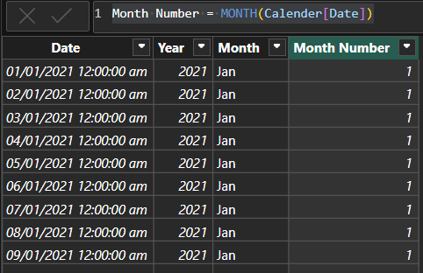

## Data Modelling:

Joining tables, building ERD, in this phase I created a relation between accident dates and our date table “DATE”. M:1 relationship as many accidents can occur on one date. Primary key and foreign key.

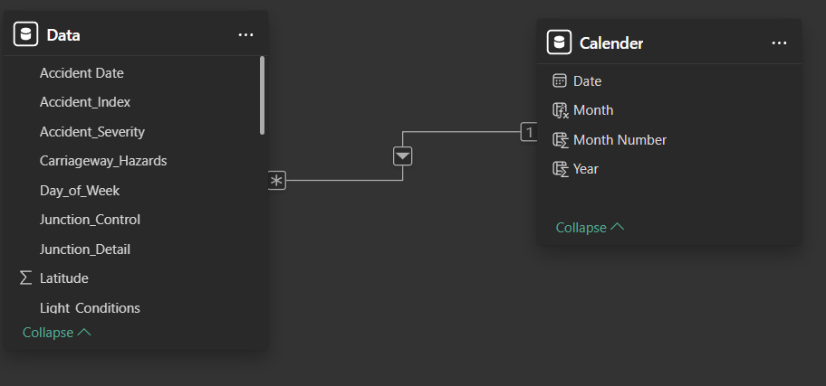

## Design:

After all these steps its time to design a background and template of the dashboard. It can be done using Canva, Figma, power point.

## Data Visualization:

### Primary KPI:

Requirement: Total casualties and total accidents for current year and year on year growth mean how much increase and decrease happened I percentage from previous year a reminder that our data is from 2021 to 2022.

To get the current year casualties and accident we have to extract 2022 casualties and accidents from overall casualties table and accident_index.

CY Casualties = TOTALYTD(SUM(Data[Number_of_Casualties]),Calendar[Date])

TOTALYTD function is a time intelligence function that give us year to date data.

We created a new measure for it by going into modelling. (YTD,QTD,MTD)

CY Accidents = TOTALYTD(COUNT(Data[Accident_Index]),Calender[Date])

All of these are done by using DAX (Data Analysis Expression)

Now to calculate previous year accident and casualties.

PY Casualties = CALCULATE(SUM(Data[Number_of_Casualties]),SAMEPERIODLASTYEAR(Calender[Date]))

PY Accidents = CALCULATE(COUNT(Data[Accident_Index]),SAMEPERIODLASTYEAR(Calender[Date]))

“SAMEPERIODLASYYEAR” function.

Now to calculate the year to year(YOY) growth we gonna use current year and previous year data.

YOY Casualties = ([CY Casualties]-[PY Casualties])/[PY Casualties]

YOY Accidents = ([CY Accidents]-[PY Accidents])/[PY Accidents]

This gives us a percentage of casualties this year with respect to last year.

Use a CARD to precent the casualties and accidents do its formatting and use required measures like CY casualties and YOY Casualties.

## Primary KPI2:

Requirement: Total casualties of this year with respect to accident severity.

Use the same previous data just add a filter with different accident severity type just like fatal, serious and slight.

## Secondary KPI:

Requirement: total casualties with respect to vehicle type for current year and previous year.

Added png transparent background stickers by insert-> image. Used pixLr tool to remove background, there were many vehicle types to I grouped the ones that fall in the same category. Used grouped VEHICLE_TYPE and CY CASULTIES.

## Charts:

Requirement (line chart): Monthly trend of casualties for current and previous year.

Area chart, fields were month on x axis and sum of casualties on y axis. Sorted the legend using date by year as without that the months will be sort alphabetically so we created month number column in calendar table.

Requirement (vertical bar): Casualty by road type for current year, single road double road.

Stacked bar chart, fields were current year casualties and road type.

Requirement (Donut): Current year casualties by area(urban/ruler) and day/night.

Used donut I both grouped light condition for one donut and used the rest as they were and showed data in terms of numbers and percentage.

There were a lot of formatting that has been done as can be seen in the overall dashboard

## Map:

Requirement: Total casualties with respect to location and number of vehicles.

Use map, add latitude and longitude and location. One thing to add is tooltips which are casualties and vehicle sum in respected area.

## Filters and Slicers:

Select a visual go to format then edit interaction.

Can change the highlight option into filtering. And if don’t want any particular chart to change then filter is applying and turn it off too.

Added two slicers on the top right corner. Weather condition and Road surface. Using these slicers by using slicer we can filter out the whole dashboard according to the requirement.

Also used text box to add titles.

## Final Dashboard: can add video as well. (figuring out how to deploy)

